Detailed Game Specifications:  
Tetris

Course: COMP 2659, Winter 2015  
Instructor: Paul Pospisil  
Author(s): James MacIsaac & Brad Ritten  
Last Modified: 15/04/2015

# 1. General Game Overview

A one or two player game set in a rectangular area of cells where blocks of various shapes constantly drop from the top at a given pace (based on difficulty level), and then lock in to place when they hit the bottom of the play area, or make contact with another block already in position. The user has control of the orientation of the block prior to in falling into place. The user can eliminate blocks if they can complete a row. Points are awarded for row completion. The two player version would be a sequential game where one player would go first, then the other would go second. The scores would then be compared.

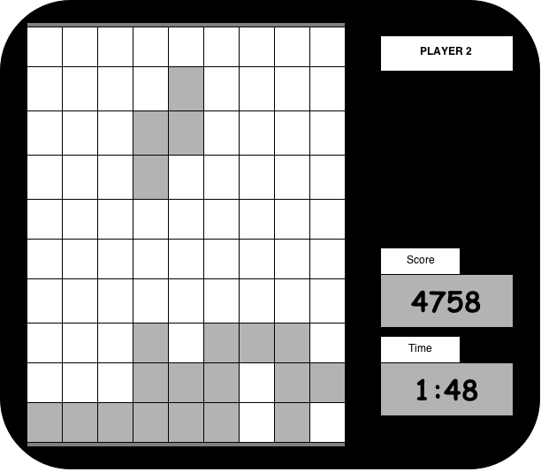

# Core 1-Player Details:

## Overview

One at a time, randomly generated blocks of varying shapes will drop from the top of the play area. The player will be given a set of controls to allow them to turn and shift the blocks as they fall from the top towards the bottom of the screen. The objective is for the user to position these blocks, as they fall, in a fashion as to complete rows of blocks from the left side to the right side of the play area. Completing this objective results in points being awarded which are added to the player’s running score. Once completed, the blocks forming this line are removed from the play area, and all blocks above this row get shifted down one level. Play finishes once the blocks stack such that adding a block is not possible since it would no longer fit on the screen. Time is kept track of to be seen alongside a player’s score.

1-Player in-game view:

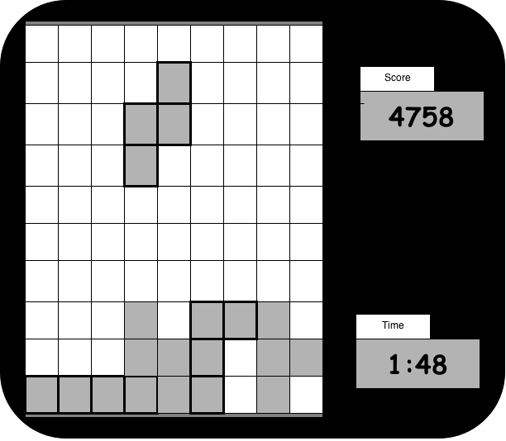

## Objectives and Rules

The start state of the game includes a menu. The user will be prompted to hit a key to begin. Once this has been achieved, the game time will start, the first block will start appearing from the top of the screen, and the user will have to begin using strategy to place the blocks in a way that will allow them to complete lines across the screen to gain points.

Objective:

The user will be trying to maximize their score and minimize their time simultaneously to achieve the best that they can. A Score category system may be implemented.

Rules:

The rules behind the game are fairly simple. The user gets to control the movement of a randomly generated, slowly falling block. This includes commands to rotate (not to be confused with flipping!) the block in either direction and a command to speed the falling process of the block towards the bottom of the screen. Once contact is made with either the bottom border of the play area or another block, this block is in its final position. A short time delay between when contact is made with an obstacle and when the block is considered to be in its final position must be allowed to make last moment rotations of the block, if any are available. There are 7 unique block shapes that can be generated. Each has up to 4 possible orientations (interchangeable with the rotation mechanic). More information on these shapes is found in the Objects Section.

Scoring:

Scoring is summed up throughout a game. Points are awarded each time 1 to 4 completed horizontal lines of blocks are completed at the same time. Scoring works as follows:

* 1 Line: 40 points
* 2 Lines: 100 points
* 3 Lines: 300 points
* 4 Lines: 1200 points

Once the player has stacked blocks to the top of the screen such that the next block generated can no longer be fully visible on the screen, the game is over, and we will be shown the player’s final score, game time, and a congratulatory message if any medals are to be awarded. In a potential additional implementation of a leaderboard database, each player would pick a username under which to play. The highest scores would then be kept and made available to anyone else playing the game.

## Objects

|  |  |  |  |
| --- | --- | --- | --- |
| Object | Properties | Behaviours | Graphical Image |
| All Blocks  (common properties) | * Start position:   Centered at the top of the play area.   * End position:   User controlled during the game. | * Falls from the top of the screen towards the bottom at a standard rate, unless told to accelerate by the user. | All images follow |
| Square Block |  | * Rotating this object has no effect since it is a square. | C:\Users\James\Downloads\SquareBlock.png |
| Zig-Zag Block (right) |  | * Two possible orientations are available, chosen and interchanged by user input | C:\Users\James\Downloads\SquareBlock (1).png |
| Zig-Zag Block (left) |  | * Two possible orientations are available, chosen and interchanged by user input | C:\Users\James\Downloads\SquareBlock (2).png |
| Straight Block |  | * Two possible orientations are available, chosen and interchanged by user input |  |
| Corner Block (left) |  | * Four possible orientations are available, chosen and interchanged by the user in-game | Macintosh HD:Users:James:Downloads:SquareBlock (2).png |
| Corner Block (right) |  | * Four possible orientations are available, chosen and interchanged by the user in-game | Macintosh HD:Users:James:Downloads:SquareBlock (3).png |
| T-Block |  | * Four possible orientations are available, chosen and interchanged by the user in-game | Macintosh HD:Users:James:Downloads:SquareBlock (4).png |
| Cell | * A single cell in the play area * Can either be filled with a portion of a game block or empty at any given time in the game(Black or White) * Dimensions of 16px*16px | * Remains fixed in its position for the entirety of the game * User actions will either fill or empty the cell. | Macintosh HD:Users:James:Downloads:SquareBlock (5).png |
| Play area | * The entire set of cells for gameplay * Set is 10 cells wide and 18 cells high * Dimensions of 160px*288px | * Fixed grid of cells in which all of the gameplay happens * Cell interaction must be ran through this object | Macintosh HD:Users:James:Downloads:Tetris diagram (2).png |
| Score | * The score object keeps track of the players progress gradually throughout the game * Updated whenever the player accumulates points | * The score will remain fixed in position in the user interface and must be updated immediately following a scoring move by the player |  |
| Time | * The time object keeps track of how long the game has been running * Time is halted once the game is over | * The time object will advance itself from when the user starts the game until the user causes the game to enter the ‘loss state’ |  |

## Physics

The only physics behind the game idea that need to be visited are:

* Play area edge collision
* Block collision
* Constant drop rate of blocks

The scheme I am going to propose to accomplish these three aspects will be to set up a cell coordinate system ( 10 x 18 grid -> 0 through 9 for horizontal cell rows, 0 - 17 for vertical cell columns). This will facilitate making the play area collision (reject anything outside the grid) and the block collision (“current block in cells C1,C2,C3,C4 has collided with a filled cell at cell B3 -> set the current block’s position as its final position and generate a new current!”).

As for the movement pace of the blocks, a one row per second drop rate should keep the game simple enough that the user can play but not too long that no enjoyment can be had. The user however can always speed the descent of the block by hitting the down key.

## Asynchronous (Input) Events

|  |  |  |
| --- | --- | --- |
| Event Name | Triggering Input Event | Description |
| Shift block | < and > arrow keys | The right and left arrow keys will instantaneously shift the current block, retaining orientation of the block, right or left one cell, respectively. This can be used as often as the user would like. |
| Rotate block | ˄ arrow key | This command will shift the orientation of the current block 90 degrees in a clockwise fashion, as to allow the user to place the blocks in an organized fashion. This can be used as often as the user would like. |
| Accelerate block | ˅ arrow key | This command will increase the rate at which the current block will descend towards the bottom of the screen. This allows the user to speed up a block already in position and proceed to the next block. The rate of acceleration will be 1 click to move 1 cell (not counted in the 1 cell per second rate of descent). |
| Update score | The user has successfully scored points by completely filling a horizontal line with blocks | This event will call for the user score to be resumed. The old score must be added to the newly scored points to generate the current total score. This will update the score object in the UI |
| Update grid | A player scoring | Once the score has been updated, the grid must first get rid of the row(s) of cells that were completed and shift all cells in their final position above the completed cell downwards by exactly one cell. This will be the new grid that the user is to play with. |

NOTE: score updating and grid updating must be completed virtually instantly one after another to allow the game to continue without a pause.

## Synchronous (Timed) Events

|  |  |  |
| --- | --- | --- |
| Event Name | Trigger Timing | Description |
| Block descends | Every 70/70th of a second | Current block descends one block maintaining its current orientation and shape |
| Block collision | When a block descent results in a collision | Once the collision is detected between the two cells, the user will be given 70/70th of a second to shift the block and orient the block ( if the surrounding grid schema allows rotation freely without other immediate collisions) to allow the user a final positioning phase for this block. |
|  |  |  |
|  |  |  |

## Condition-Based (Cascaded) Events

|  |  |  |
| --- | --- | --- |
| Event Name | Triggering Condition | Description |
| Starting the game | The game start is triggered when the enter key is hit | This will cause the game to initialize (created the grid, make it visible to the user, start the time, and generate the first block). The first block will then begin the synchronous descent event and user control will be granted for that block. |
| Final block isolation | Block is in final position on the grid | When the final position timeout ends ( after 70/70th seconds, the user loses control of the current block, all of the blocks current cell locations must become filled cells on the grid, allowing the cells to cause collisions and be used in point scoring routines |
| Full row checker | A full row of blocks is completed | This will cause the system to award the user points, and to remove the blocks constituting the row(s) from the game. Then all rows above said row(s) will need to be shifted down by 1 cell for each row removed. |
| Score and time updater | Score or time has changed | The screen must be updated to reflect changes in these aspects. Time will happen at a specific rate whereas the score must be triggered. |
| Block generation | When time starts OR a new block is needed | When time starts, the game will generate a random block with a random possible orientation that will be centrally positioned at the top of the screen and begin to descend towards the bottom at a fixed rate. The user will be granted control with their 4 commands of the block. This must also happen upon the loss of control of a block that has reached and successfully been positioned by a collision. |
| Ending the game | When a newly generated block is not able to display its entire shape onto the screen via synchronous descent | Once this event has occurred, the game time must end and be recorded at its final state, the game score must be recorded, and both must be displayed to the user for contemplation. |

## Hypothetical Gaming Session

* User has started the game by hitting the enter key
* Current block is a zig-zag (left) block with horizontal orientation
* Block descends one cell
* Block descends one cell
* User shifts the block to the right 2 spaces
* Block descends one cell
* User shifts the orientation of the block one time
* Block descends one cell
* User shifts the block to the right one cell
* …
* Block components at cell [X, Y] have had a collision with the bottom boundary of the game board at position [X, Y-1].
* Block final position timeout has commenced.
* User has shifted the block one cell to the left
* Block final position timeout has completed, block is now in final position. User control has been terminated on the block
* Block cells have been changed to filled cells on the board
* Current block is a Corner block (right) with orientation 1
* Block descends one cell.
* ……………………………………
* Current block is a straight block with vertical orientation
* Block attempted to descend one block but a collision was detected. Block cannot be fully represented on the screen. Game is over
* Record time, score
* Display stats to user

# 3. Game Play Details for Core 2-Player Version

The two player modification of the game will be selected from a menu when the game starts up. The users will then go one after the other. Each player plays as long as they can until the game ends for them. Once both players have ended their individual turns, the game will display scores and announce who has won the game.

The 2 player version is identical to the one player version in terms of playstyle.

The user interface will appear identical to the 1 player version apart from a player name displayed in the top right of the window.

# Macintosh HD:Users:James:Downloads:Tetris diagram.png

# 4. Sound Effects

|  |  |  |
| --- | --- | --- |
| Sound Effect Name | Brief Description | Event which Triggers Playback |
| Start | A short tune to be played to signal the start of play | User hits the enter key to start the game |
| Rotation | A tiny ‘power-up ‘- like sound to signal that the user has rotated the current block one time. | User hits the rotate key |
| Score | A small trumpet sound of some form to congratulate the user on scoring some points | User successfully makes a complete horizontal line of filled cells |
| End | A sad sound appears to signal the end of the game | User loses ends their game (or turn) |
|  |  |  |

The Tetris theme song plays in the background.

# 5. Additional Features (Time Permitting)

* Score category system:

A scoring system with a few simple guidelines:

* A Score above 3000 points with any time limit awards the player a bronze medal!
* A Score above 6000 points in under 5 minutes awards the player a silver medal!
* A score above 9000 points in under 7 minutes awards the player a gold medal!

This system will allow players to strive to achieve a higher score in a shorter time limit.

* Grey-scale coloring of blocks and the grid:

Adding some grey scale color to make easy distinctions between different objects. Possibly make the user interface look a bit sleeker as well.

* A “Next Block” window:

This window will contain the block that the user will be given control of once the current block has been placed in its final position. This will give the user some added gameplay strategy by allowing them to plan their moves ahead of time. The shape, and orientation will be made apparent.

* A Leaderboard display:

This will allow the user access to a game history ‘database’ of a sort. User will be required to select a username to play under. Both 1 player and two player games will be added to rankings in the leaderboard. The user could the consult the leaderboard to see what username achieved the highest score in the lowest time, or also the lowest time with the highest score. This would also alter the user interface when a game finishes to display the leaderboard in a simplified format, and to congratulate users on taking top positions on it.

* Flash graphics:

These will be small graphics that make cells flash when they are disappearing. Not sure what to think as far as an implementation goes but I have seen it in some tiny html5 versions and it adds ‘flavor’ to the game along with the sound portion.

* Cool looking game logo and simplified splash art:

A small graphical logo that is more appealing that just writing the word Tetris. Some splash art could include a picture converted to a graphic form. (I would probably try and make people laugh with this part). These could also be added to the grid area to make it look more appealing as well.

* Color graphics:

This probably won’t happen but it would drastically improve the way the game looks. This would include varying block colors, colored Interface, flashy UI objects, etc.